🏊 The "Double-Session" Recovery Guide (Ages 9–16)

⏱️ The 4-Hour Timeline
- 0–20 mins: Refuel & Flush. Drink 16oz water/electrolyte mix. Do a 5-minute easy swim (warm-down) to flush muscles.
- 20–60 mins: The Golden Snack. Eat high-carb + moderate protein (e.g., chocolate milk or a banana with PB).
- 60–120 mins: Deep Rest. Get out of the sun. Shower (rinse chlorine). Eat a small, light meal.
- 120–180 mins: The Reboot. Optional 20-min power nap. Feet elevated above heart level.
- Last 30 mins: Prime. Pack bag, sip water, and do dynamic arm swings before heading back to the deck.

🥗 Fueling the Gap
The Rule: Choose "Fast" carbs that won't sit heavy in your stomach. Avoid fried foods, heavy fats, or high-fiber beans/salads during this short window.
The Best "Quick" Snacks | The "Small Meal" (If hungry)
Low-fat chocolate milk | Turkey and cheese wrap
Greek yogurt + honey | Plain pasta with a little parmesan
Pretzels + hummus | Half a bagel with almond butter
Fruit smoothie (not too much fiber) | Chicken and rice (small portion)

💧 Hydration & Body Care
- The Urine Test: If your pee is dark like apple juice, you are dehydrated. Aim for "pale lemonade."
- The "Feet Up" Trick: Lie on your back with your legs resting against a wall for 10 minutes. This helps drain fluid buildup and refreshes tired legs.
- Chlorine Rinse: Use a Vitamin C spray or swim-specific soap immediately. Skin is an organ; if it’s "itchy" or "tight," your body is using energy to fight irritation instead of recovering.
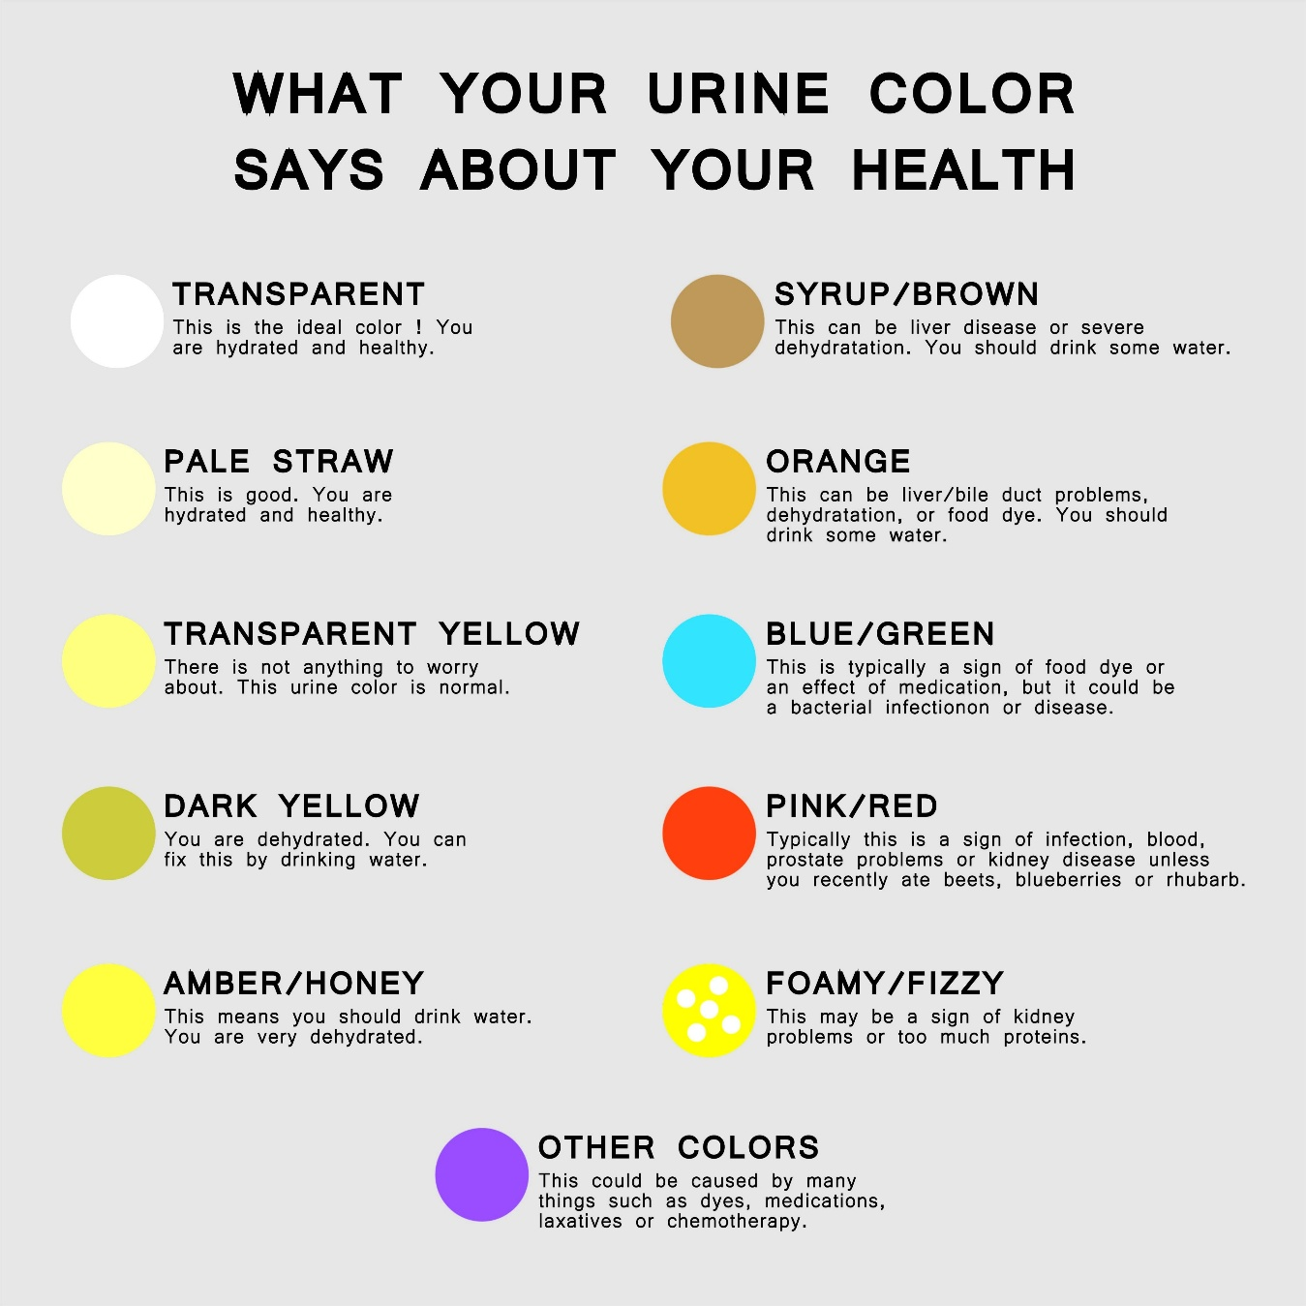
Shutterstock

🧠 Mental & Sleep Recovery
- The 20-Minute Nap: Do not sleep longer than 30 minutes, or you will wake up feeling "heavy" and "foggy" (sleep inertia).
- Digital Sunset: Spend 30 minutes away from your phone. Scrolling TikTok/social media drains "mental energy" that you need for focus during the second practice.
- The Reset: If the first practice was bad, "leave it in the water." Dry off your skin, dry off your mind.

🎒 The "Between-Practice" Checklist
- [ ] Change of clothes: Get out of your wet suit immediately (save skin/energy).
- [ ] Extra towel: Always have a fresh, dry one for the second session.
- [ ] Electrolyte powder/drink: To replace salt lost in the first swim.
- [ ] Foam roller/Tennis ball: For 5 mins of rolling out tight lats/shoulders.
Would you like me to create a specific "Grocery List" of these recovery foods for your next shopping trip?

